Instructions for using the online volunteer hours form
V2 10/3/2023

Creating a new account in the Vermont Fish & Wildlife Department Volunteer Reporting Form
- Open a new tab in your internet browser and open this link Vermont Fish & Wildlife Volunteer Reporting (vt.gov)
- For first time users, you need to create an account first. Click “REGISTER”
- Fill out the fields and create a new password (THAT YOU CAN REMEMBER)

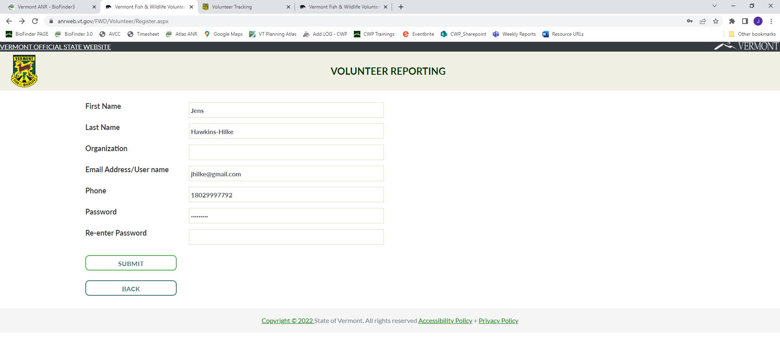
- Click on “SUBMIT” to create your account.
- You will see confirmation that it was successful and have the option to log in.
- Click on the text to log in.

Logging in to the Vermont Fish & Wildlife Volunteer Reporting (vt.gov)
- Vermont Fish & Wildlife Volunteer Reporting (vt.gov)
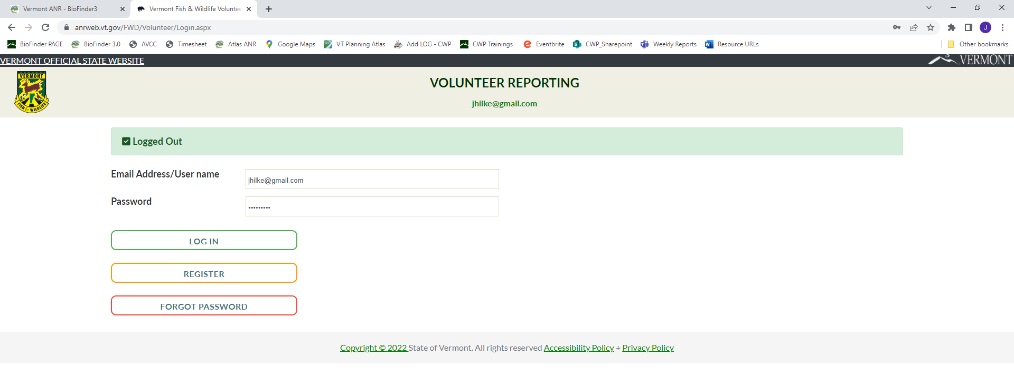
- Once you are logged in, follow the link “CONTINUE TO SURVEY”
- In the Volunteer Information Section, Fill in your name and email
- Under Project Category select ___Birds_____
- Under Project Name Select ____Field Surveys_____
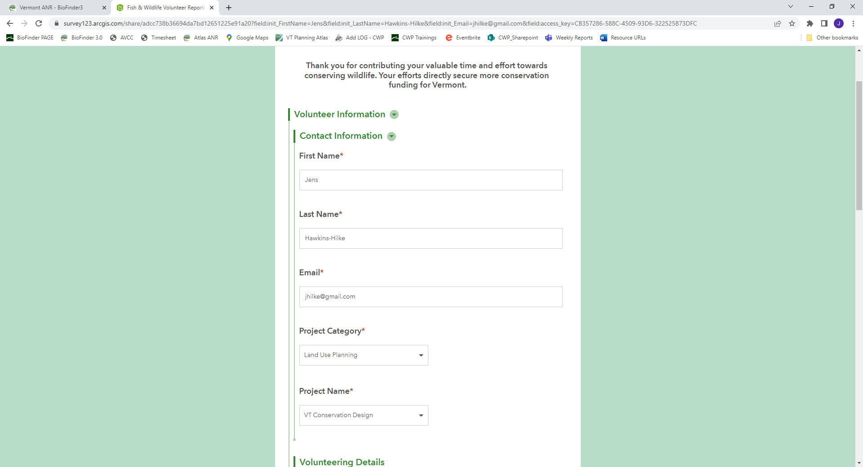
- In the Volunteering Details section,
- Enter Activity Description field
- Enter the select Activity Date. For each Date of service, you’ll need to fill out the Volunteering Details section again.
- add mileage (if any), Round Trip hours spent driving (if any)
- Add Hours spent on activity only. Please estimate to nearest 0.25 hours.
DO NOT CLICK SUBMIT (Yet)IF YOU WANT TO ADD MULTIPLE DATES!
For each Date of service, you’ll need to fill out the Volunteering Details section again.

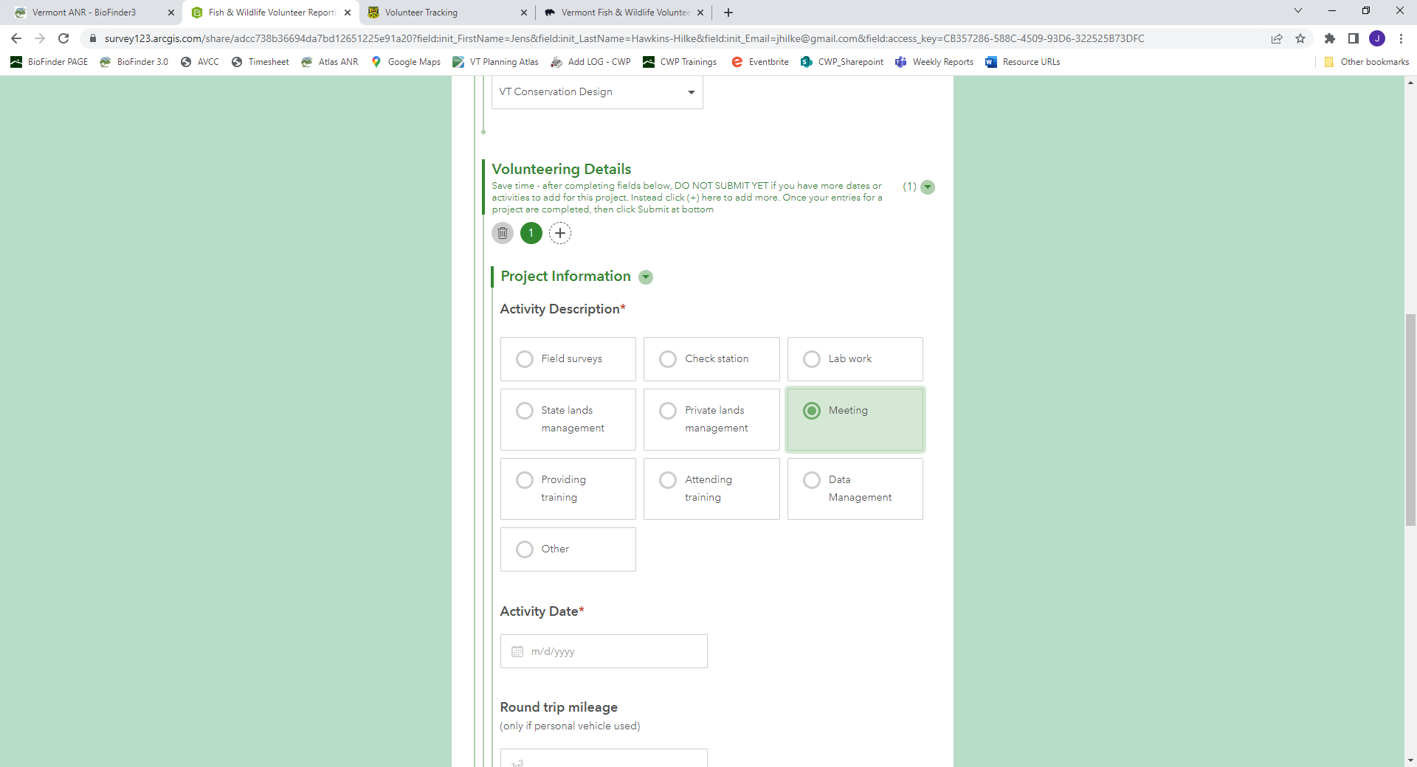

To add multiple dates of volunteer activity
- Scroll back up to the top of the Volunteering Details section.
- Click on the + sign on the right of the digits. This opens an additional section
- Fill out the Project Information section for an additional date of service
- In the Activity Description field, select “meeting”
- Enter the select Activity Date,
- add mileage (if any), Round Trip hours spent driving (if any)
- Add Hours spent on activity only. Please estimate to nearest 0.25 hours.
You can add as many dates of service as you want. Click on the + sign under the Volunteering Details section to add another date.
- When you’re finished Verify Volunteer Submission by clicking yes
- Click on the “Submit” button to finish.

